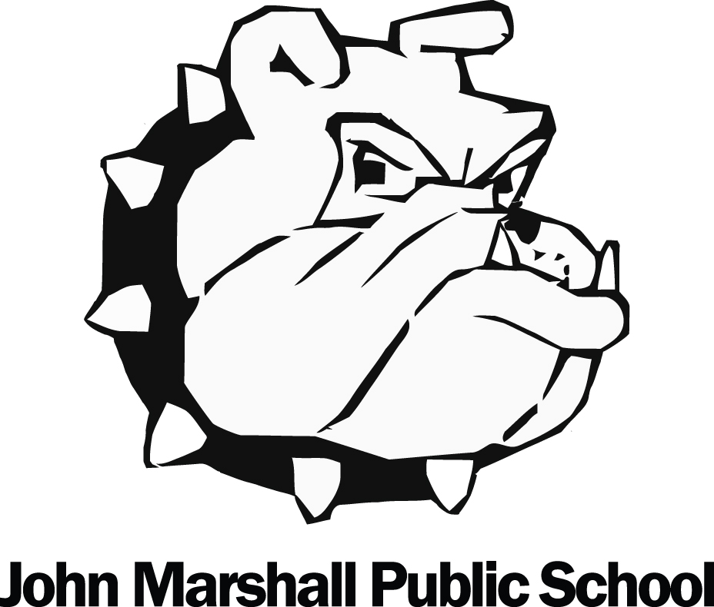 John Marshall March | 2024
Sunday | Monday | Tuesday | Wednesday | Thursday | Friday | Saturday
 |  |  |  |  | 1 | 2
Lunch Lady orders are due by Thursday 7am (the day before) |  |  |  |  | Lunch Lady hot lunch  Spin to Win
3 | 4 | 5 | 6 | 7 | 8 | 9
 | 7/8 to DSBN Living Campus | Pizza orders due | Snack Day |  | Pizza Lunch  Spin to Win
10 | 11 | 12 | 13 | 14 | 15 | 16
Immunization clinics all week: contact Niagara Public Health 905-688-8248 | MARCH BREAK  School closed all week |  |  |  | Bingo @ Delta
17 | 18 | 19 | 20 | 21 | 22 | 23
 | KDG deadline for Public Health fluoride treatment | Pizza orders due | Snack Day | Gr. 8 Grad photos | Pizza Lunch  Spin to Win
24/31 | 25 | 26 | 27 | 29 | 29 | 30
 | KDG Public Health Dental visit(fluoride) | School Council 6pm | Snack Day  Lunch Lady orders due for Friday | Spin to Win | Good Friday  School Closed
 | Parents: Register for School CashOnline and School Messenger through our John Marshall website. | Spin to Win Fridays! 24 weeks of prizes! Get your tickets thru SchoolCashOnline, draws are every Friday.  Lunch Lady hot lunches: order.thelunchlady.ca. | Apr. 1 – Easter Monday schools closed  5 / 19 – Lunch Lady  10 – Hearing/vision clinic  12 / 26 – Pizza lunch

